-- NORMALIZED TRANSFORMATION

-- M_CUSTOMER_BANK

WHERE CUSTOMER WILL HAVE ACCOUNT WITH MULTIPLE BANKS YES OR NO IF, HE/SHE HAS AN ACCOUNT THEN STORE IT IN THE DB WITH

BELOW STRUCTURE

WILL HAVE A RELATIONAL TABLE

CREATE TABLE NOR_CUSTOMER_BANK_SRC(

CUSTID NUMBER PRIMARY KEY,

NAME VARCHAR2(33),

LOCATION VARCHAR2(30),

ICICIBANK CHAR(1),

CITIBANK CHAR(1),

HDFCBANK CHAR(1),

HSBCBANK CHAR(1));

INSERT INTO NOR_CUSTOMER_BANK_SRC VALUES(1, 'NAVEEN', 'BENGALURU', 'Y','N','N','N');

INSERT INTO NOR_CUSTOMER_BANK_SRC VALUES(2, 'SUNDAR', 'RESTON', 'Y','Y','N','Y');

INSERT INTO NOR_CUSTOMER_BANK_SRC VALUES(3, 'TIM', 'NEY YORK', 'Y','N','Y','Y');

CREATE TABLE T_NOR_CUSTOMER_BANK(

CUSTID NUMBER,

NAME VARCHAR2(33) ,

LOCATION VARCHAR2(30),

BANK VARCHAR2(20));

Normalizer iconic view 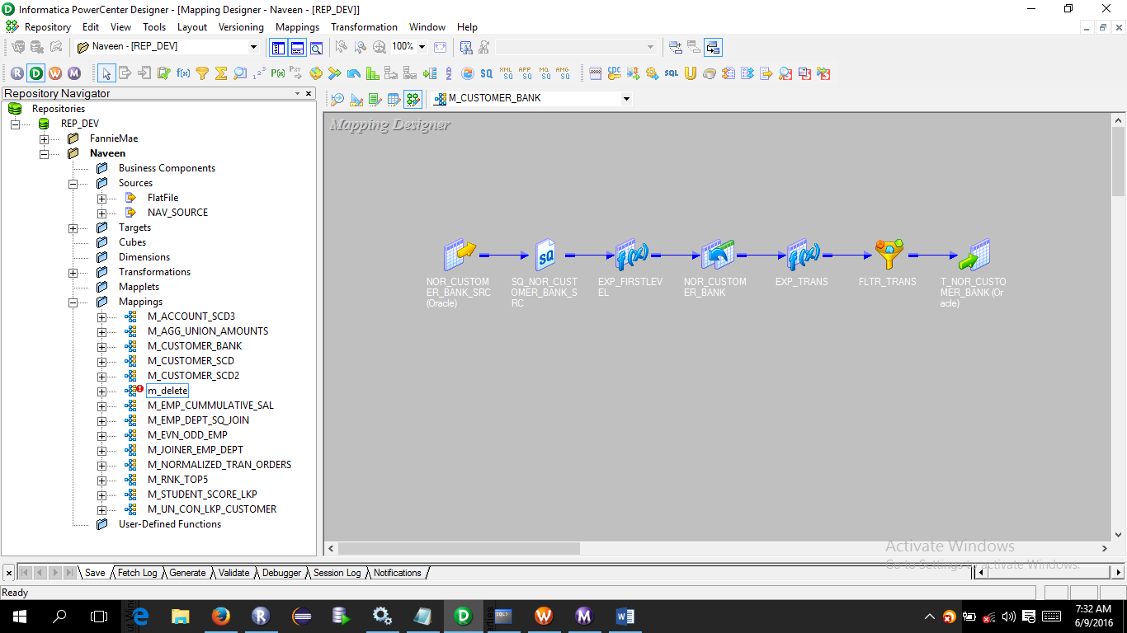

As a good practice have a expression, from source qualifier

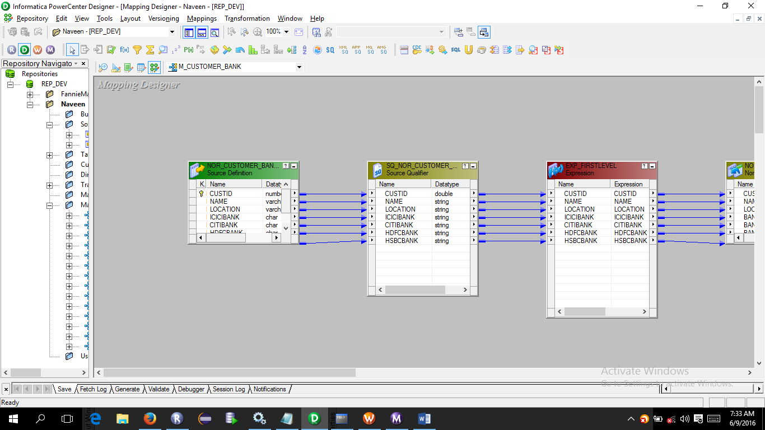

Create a Normalizer transformation

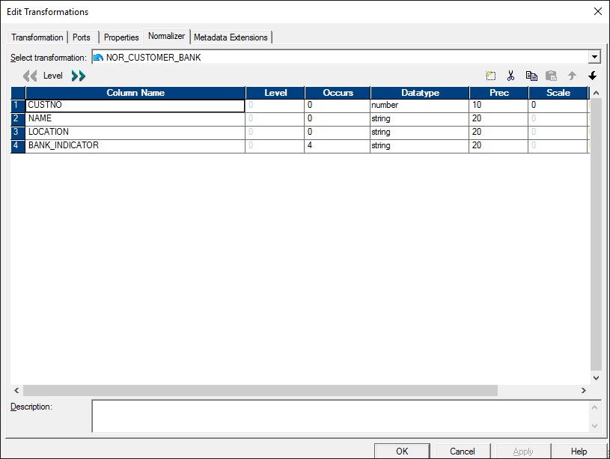

Under Normalizer create the ports which are required in target table, Here Bank_indiacator will have which tell either the customer has ‘Y’ or ‘N’

Create a expression

Have V_BANK_NAME to substitute for the bank name, and give the output port to O_BANK_NAME

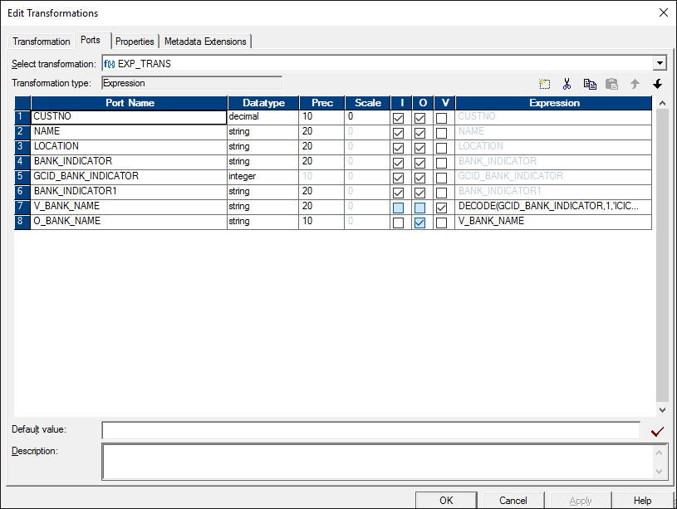

Now both entries are given ‘N’ or ‘Y’ we can use filter transformation to send only ‘Y’ entries.

